November 07, 2025

The Honorable Roger Wicker The Honorable Jack Reed
Chairman Ranking Member
Senate Armed Services Committee Senate Armed Services Committee
228 Russell Senate Office Building 228 Russell Senate Office Building
Washington, DC 20510 Washington, DC 20510

The Honorable Mike Rogers The Honorable Adam Smith
Chairman Ranking Member
House Armed Services Committee House Armed Services Committee
2216 Rayburn House Office Building 2216 Rayburn House Office Building Washington, DC 20515 Washington, DC 20515

Dear Chairmen Rogers and Wicker, Ranking Members Smith and Reed:

As you prepare for conference negotiations on the Fiscal Year 2026 National Defense Authorization Act (NDAA), we write to strongly urge the inclusion of the text of the Drone Espionage Act, which would fill a technical gap and prohibit video surveillance of sensitive defense sites in addition to still photography which is currently prohibited.

Drones are increasingly used by America’s adversaries, particularly China, to capture video of sensitive national defense sites. Although it is already illegal under the Espionage Act to take photos of national defense sites, the statute currently makes no mention of videography and leaves our laws exposed to potential circumvention by our adversaries. For example, in the Middle District of Florida, a suspect was found to have recorded significant amounts of video over one of our national defense sites in Cape Canaveral. Over the course of the investigation, the prosecutors could only charge for possession of the still image despite possessing significant amounts of footage. Without those still images, the U.S. Attorney in the Middle District has said this individual may not have been held accountable for these acts of espionage. Unsurprisingly, this case is not unique and is becoming more frequent across America. The only way to uphold the integrity of our national defense sites is to ensure our laws are updated to meet the technological advancements of the times.

As such, this bill updates the Espionage Act of 1917 to include videography of sensitive national defense sites as a crime, amending Sec. 793 by adding “video” to the list of criminal information-gathering means by those seeking to harm the national defense. The text of this bill was included in Section 1089, S. 2296, the National Defense Authorization Act of 2026. The text of the bill is as follows:

Section 793 of title 18, United States Code, is amended by inserting ‘‘video,’’ after ‘‘photographic negative,’’ each place such term appears.

Thank you for your continued leadership in ensuring this year’s NDAA strengthens our defense capabilities, supports those who serve, and invests in the people and places that make our national security possible. I look forward to working closely with both committees to ensure these priorities are reflected in the final conference agreement.

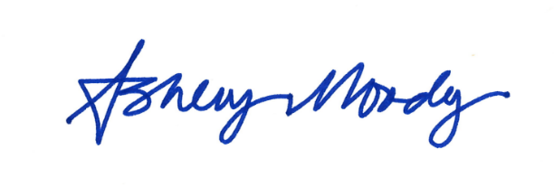
Sincerely,

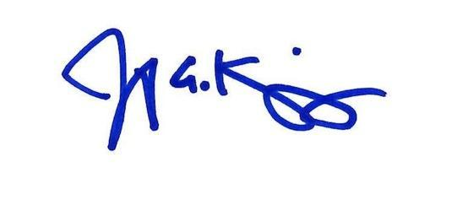

Ashley Moody Jen Kiggans
United States Senator Member of Congress

